### A Summer Internship Project Report on

**“Study of Accounting and GST filling of Small and Medium enterprises”**



Submitted To



Submitted By

**Kumari Sakshi Mishra**

**Roll No. BA2432**

**PGDM- BUSINESS ADMINISTRATION (FINANCE)**

In partial fulfilment of the requirements for the award of

#### **POST GRADUATE DIPLOMA IN MANAGEMENT (PGDM)**

**2024-2026**

**Certificate (Internal SIP Guide & HOD Signature)**

**DECLARATION**

I Kumari Sakshi Mishra, a student of PGDM Business Administration at MIMA Institute of Management, Pune, declare that this internship report titled " **Study of Accounting and GST filling of Small and Medium enterprises** " is based on my work during the summer internship at CA Dhiraj Ostwal & Co. The contents are original and have not been copied from any source, except where properly acknowledged.

Date: PUNE, MH

Place: September 22, 2025

Signature :

Kumari Sakshi Mishra

BA-2432



**ACKNOWLEDGEMENT**

I would like to express my sincere gratitude to all those who have supported and guided me throughout the course of my internship.

First and foremost, I would like to thank Mr. Neeraj Gawade, my internship supervisor at, CA Dhiraj Ostwal & co. for their valuable guidance, support, and encouragement during the internship period. Their insights and feedback have been valuable.

I would also like to thank Dr. Sachin Lele at Mima Institute of Management for their continuous support and for giving me the opportunity to pursue this internship.

I extend my gratitude to all the employees of CA Dhiraj Ostwal & Co. who contributed in some way to my learning experience and made me feel welcome.

Finally, I would like to thank my family and friends for their constant support and motivation throughout this journey.

Date: September 22, 2025

Place: PUNE, MH

Signature:

Kumari Sakshi Mishra

BA-2432

**Certificate of completion (Company)**

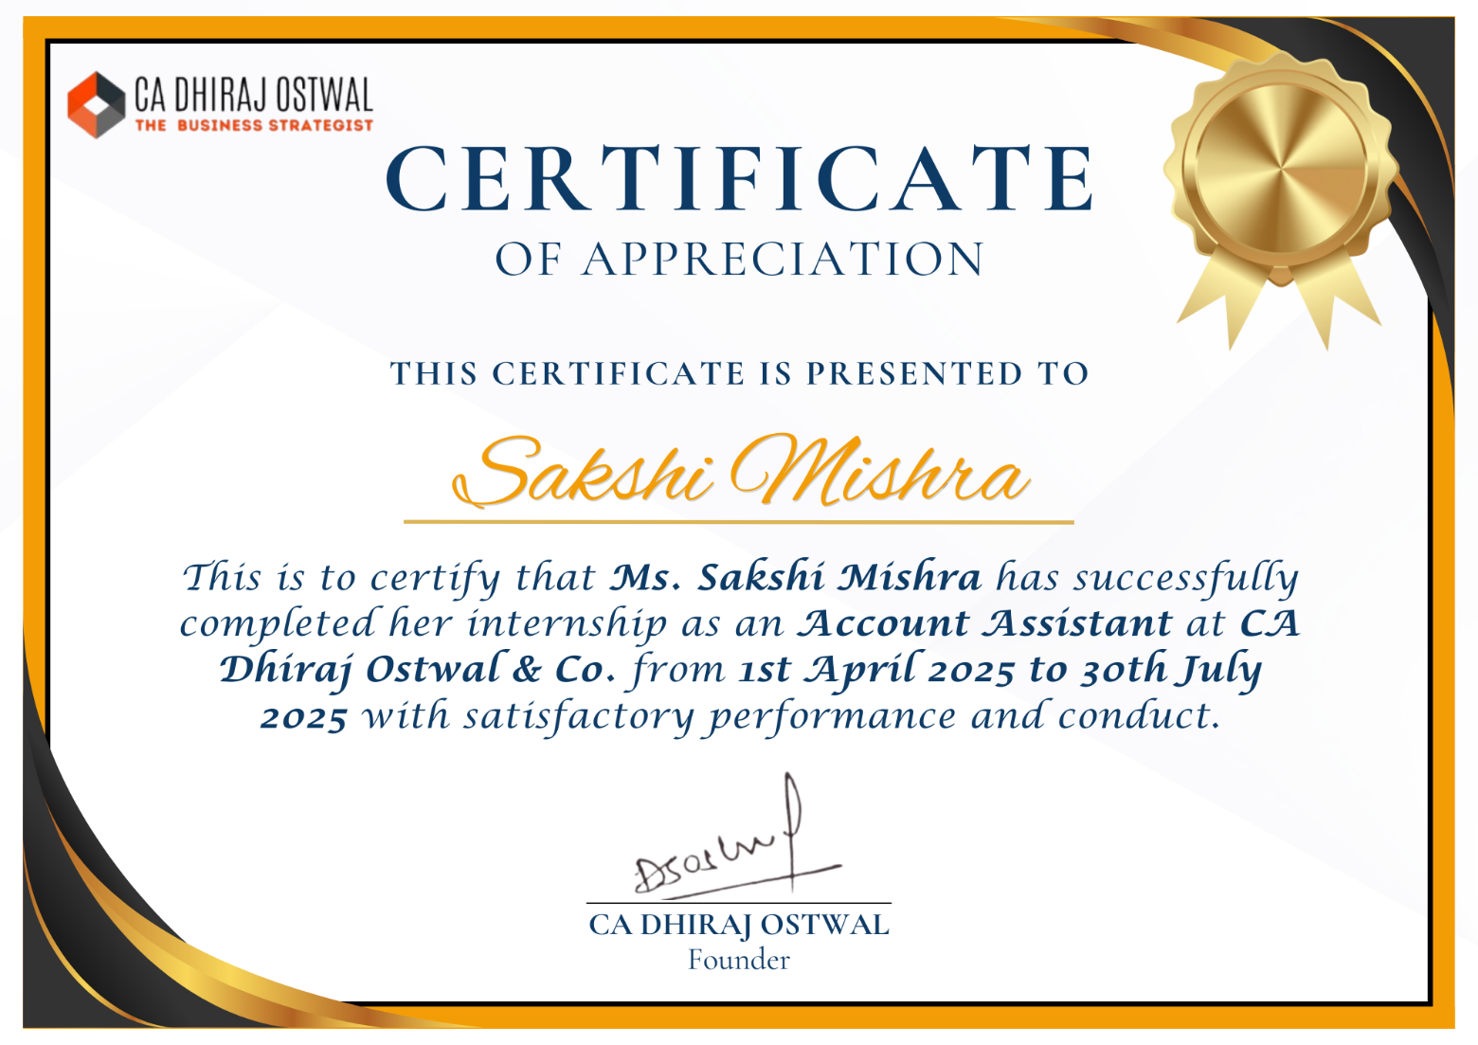

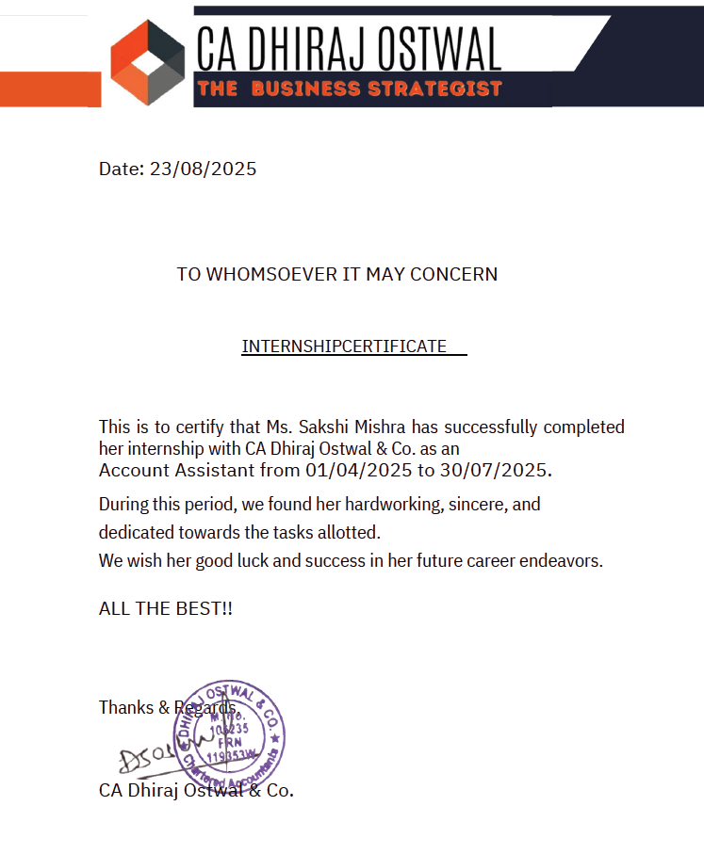**SIP Feedback**

TABLE OF CONTENTS

|  |  |  |
| --- | --- | --- |
| **Sr. No** | **Particulars** | **Page No.** |
|  | **Executive Summary** | **8** |
| 1 | **Introduction** | 10 |
|  | Scope and Importance of Study | 10 |
|  | Literature Review | 10 |
|  | Objectives of Study | 13 |
|  | Limitations of Study | 14 |
| **2** | **Company Profile** | 15 |
|  | About Company | 15 |
|  | Organizational structure | 15 |
|  | Range of Services | 16 |
| **3** | **Methodology and Database** | 18 |
|  | Research Methodology | 18 |
|  | Database | 19 |
| 4 | **Data Analysis and Interpretation** | 24 |
|  | Results of survey | 34 |
| 5 | **Summary of Findings, Conclusions and Recommendations** | 42 |
|  | Summary of Analysis | 42 |
|  | Findings | 42 |
|  | Suggestions | 42 |
|  | Conclusions | 43 |
|  | Bibliography | 44 |

List of Tables

|  |  |  |
| --- | --- | --- |
| **Sr. No.** | **Title** | **Page No.** |
| 1. | Survey Pie Charts | 33-37 |
| 2. | GST collection Graph | 37 |

# **EXECUTIVE SUMMARY**

The report is titled **“Study of Accounting and GST filing of Small and Medium Enterprises”**.

For my study, I did an internship at “Dhiraj Ostwal and Co. The main objective of the study was to understand and analyze how the accounting of the books of the clients at the firm is done. The main reason I chose to study accounting was to study-

* How the books of accounts are maintained by the clients in the Tally software.
* How the sales and purchases entries are reconciled with the GST software.
* How the bank statements are imported into the Tally software for proper accounting.
* How the financial statements are prepared and accounting of clients is done.

I also understood and analyzed how to file the GST returns. At my firm, we use a software named “SPEQTA GST” to file GST returns and reconcile different returns. The main reason I chose to study GST was-

* How the sales entries are reconciled with GSTR-1.
* How the purchase entries are reconciled with GSTR-2A
* Filing of GSTR-1 and GSTR 3B and how to file a Nil GSTR return.
* Reconciliation of Input Tax Credit taken in books vs Returns filed by vendors.

Also, this study also highlights that clients face penalties and late fees due to non-compliance or late compliance with GST laws.

I also found out the impact of use of software such as SPEQTA GST and TALLY on the return filing and accounting of the firm.

We found out that through the use of software for filing of GST returns reduces the chances of any errors since the software itself provides real time download facility from the GST portal which can help in filing correct returns and claiming of the right Input Tax Credit. It also reduces the chances of missing the due date since the generally during the due dates of filing the returns, there is a server issue on the GST portal which can cause delay in filing the returns and which can easily lead to payment of late fees and penalty.

The software provides easy facility of reconciliation of various returns such as GSTR 1 and GSTR 3B which can make it easier for the taxpayer to check the accuracy of the return filed and avoid any notice in the future.

By using a software such as Tally, accounting can be done with less chances of errors and can help improve confidence on the Final accounts that are prepared.

In conclusion it can be said that the study highlights the gaps between the GST compliance policies and how they are implemented in real life and what challenges tax payers face while filing the returns

It also highlights the need of use of Technology for filing the returns/ doing the accounting and the need for education of all regarding the basic concept of GST.

# **Chapter 1**

# **INTRODUCTION**

The report titled **“Study of Accounting and GST filing of Small and Medium Enterprises”** aims to give knowledge about how Accounting of different clients are done in order to provide them with true and fair information and how GST returns of clients are filed on the due dates and what are the different challenges faced while doing the same.

During my initial days at **Dhiraj Ostwal and Co**. they taught me how to do the basic accounting for different clients. I got to know that whatever knowledge I had gained during my Graduation and 11th and 12th standard was really helpful since I was asked to do the bank statement reconciliation and do accounting entries. While doing the accounting entries I got to know that my firm uses a software **“Tally”** for doing accounting entries. It is a software used to do the accounting which is efficient and much better than paper records. Any inaccuracy, or mistake can be found out and it can easily be rectified.

Also, as previously mentioned, I got to file GSTR returns. For filing GST returns sessions were conducted at the firms to provide guidance on how to file GST returns. Also, I used the software of **“SPEQTA GST”** to file the returns. It is a helpful software to provide an overview of filed returns.

1.1 Scope and Importance of Study

The study is conducted from 8th March 2025 to 8th May 2025. During this period, the scope and importance of this study was-

* Analyzing the methods and systems SMEs use for financial record-keeping, reporting, and compliance, especially in the context of GST regulations.
* Understanding GST and its impact on SME’s and the different type of returns that are filed in GST depending upon the turnover of the client.
* Understand the importance of filing GSTR-1 and GSTR-3B.

# Literature review

Let us first get into the basic knowledge of What is Tax since GST is a part of Tax. According to ICAI, “A tax is pecuniary burden laid upon individuals or property owners to support the Government, a payment

exacted by legislative authority”. Basically, tax is nothing but money that people pay to the Government, which is used to provide public services. Now, there are 2 types of taxes

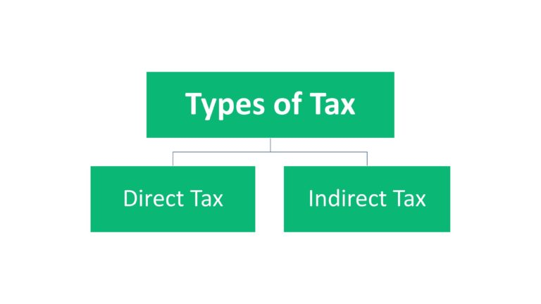

**Direct tax-** According to ICAI, a direct tax is a kind of charge, which is imposed directly on the taxpayer and paid directly to the Government by the persons (juristic or natural) on whom it is imposed. A direct tax cannot be shifted by the taxpayer to someone else. A significant direct tax imposed in India is income tax.

**Indirect Tax-** According to ICAI, If the taxpayer is just a conduit and at every stage the tax-incidence is passed on till it finally reaches the consumer, who really bears the brunt of it, such tax is indirect tax. An indirect tax can be shifted by the taxpayer to someone else. Its incidence is borne by the consumers who ultimately consume the product or the service, while the immediate liability to pay the tax may fall upon another person such as a manufacturer or provider of service or seller of goods.

Now, let us have a look at the different studies taken place in respect of GST return filing and basics of GST.

According to a research paper written by Madhu Bala named “GST In India- A Critical Review”, during the nineties Indian tax regime relied heavily on indirect taxes for revenue. However, during that period, the major argument was that major population of India was poor. Amalgamating several Central and State taxes into a single tax would mitigate cascading or double taxation, facilitating a common national market. The simplicity of the tax should lead to easier administration and enforcement. GST is expected to pave way for better e-commerce and will make industries more competitive. GST will be a game changing reform for Indian economy by developing a common Indian market and reducing the cascading effect of tax on the cost of goods and services. It will impact the Tax Structure, Tax Incidence, Tax Computation, Tax Payment, Compliance, Credit Utilization and Reporting leading to a complete overhaul of the current indirect tax system.

According to a paper named “A Comparative Study of GST Return”, published by Abhishek Katore, Professor Mahendra Yadav and Professor Rajendra Jarade, they studied the different types of GST returns such as GSTR-1, GSTR-2, GSTR-3B, GSTR-9 and GSTR-9C. They also did a comparative analysis on the complexity of filing various returns and the frequency of filing the returns. Also, they studied how now-a-days technology is used for filing the GST returns such as the GST portal where the returns can be filed electronically. They also mentioned a short brief on challenges of filing ITR returns. They also studied the implications on businesses of filing GST returns.

According to a research paper published by RajakrishnanManivel, titled “GST and Technology,” they studied use of Technology in GST. According to the research paper, the GST system has tweaked some of its features to make the system more robust and allow glitch free payment facility to facilitate nearly 35 lakh assesses. Of the total 87.33 lakh registered businesses on the GSTN, 68 lakhs were eligible to pay taxes in August. As many as 49.68 lakh returns in GSTR-3B were filed for July. This compares to 59.6 lakh businesses who are required to file returns. Taxes of over Rs 95,000 crore were collected. They also discussed about the GST portal and technology shall help in the GST compliance. The objective of Indian Government by implementing GST is to reduce and simplify the tax structure. The GST portal will help millions of people to keep a record of the invoices and also help in proper detection and prevention of frauds.

According to a research paper titled “Goods and Services Tax: Barriers in Filing GST Return and Its Impact on Accounting” presented by Shobha V., the paper explains the process of filing the return and what are the different returns that can be filed by a taxpayer. It also explains basic concepts of reverse charge mechanism, and input tax credit. Further, it explains the issues faced by taxpayer in filing GST return. Some of the issues are-

* Issues in payments not getting reflected in the Challan payment status.
* Issues regarding delay in refreshing of the “Return Status” option. This had raised ambiguity amongst the tax payers.
* Issues regarding the wrong details uploaded in the GSTR-3B for which there was no option of revising the return. This caused in wrong payment of tax providing unnecessary burden of tax on the tax payer.
* The utilities provided for uploading returns were not fully automated causing an increase in manual work

Some accounting related research-

* According to a research paper titled Information technology and the accountant today: What has really changed?” by Friday Imene Japhet Imhanzenobe published by Journal ofAccounting and Taxation, one of the major advancements in information technology (IT) is the use of IT tools to perform accounting functions and processes. They argued that in the pre- IT era, many tasks were carried out by accountants manually which led to many errors and misstatements, difficulty in storing large data on papers. According to their paper, following the emergence of sophisticated IT tools, accountants in the IT era are now able to prepare and present financial statements timely and accurately. The availability of the internet has also increased access to financial reports by external users. Now-a-days, accounting is being carried out using the software of Tally. As already discussed, Tally is an efficient software to carry out accounting and maintaining the books of accounts. It helps reduce errors and carry out timely finalization of Balance sheet. There are various other software available such as Zoho, QuickBooks, Vyapar etc.

According to a research paper titled “INFLUENCE OF TALLY ERP.9” by J. Senthil Kumar, the paper studied the impact of Tally ERP 9 accounting software in the present scenario by taking insights from accounting professionals.

According to a survey conducted by them among 33 professionals, 84.8% of the professionals are aware of the recent trends in accounting and 90.9% of the professionals are aware of the Tally ERP 9 accounting software, Also, 72.7% professionals agree that financial data analysis of Tally Erp.9 is better and 27.3% disagree. There are 84.8% professionals who agree Tally Erp.9 billing is more efficient and 15.2% disagree. Majority of the professionals agree that Tally Erp.9 minimizes the manipulations in accounting, helps in fraud detection, has better analysis of financial data, has efficient Tally Erp.9 billing options and has led to changes in the auditing process, which indicates a positive sign for future of Tally ERP 9 software.

So, we can say from the literature review analysis that study of these topics is extremely important for the future and sustainability of the small and medium enterprises.

# Objectives Of Study

* To know the in-depth knowledge about GST, how to file GST return.
* To know how to do the accounting for various clients.
* To understand the importance of filing timely returns and different types of returns that are filed.

So, in all we can say that the overall objective of this study is to provide comprehensive and detailed overview of GST and accounting.

# Limitations of Study

Many Companies do not provide timely data for compliance with GST. They provide the data after the due date. This might cause unavailability of data on a timely basis.

* The findings from studies on accounting and GST filing practices among SMEs may not be universally applicable, as SMEs vary widely by sector, region, and scale of operations.
* GST rules, tax rates, and compliance requirements are subject to frequent changes. Studies conducted at a particular time may not fully capture the impact of recent or upcoming regulatory amendments, affecting the relevance of the findings over time.
* Sometimes, while using the software of SPEQTA, there can sometimes be difference between the information present in the GST Portal (<https://www.gst.gov.in/>) and the software. This can sometimes be time consuming and can lead to confusion since while filing the returns it can be possible that the tax filed is less or the input tax credit that is claimed is more than that is allowed which can lead to penalties and fines.
* It might be possible that the information might get restricted since the company needs to maintain confidentiality of client data.
* Also, it might be possible that the client may provide the data and may require accounting to be done on an urgent basis. For example- to give the accounts to bank the next day for taking a loan. This can create pressure on the team and they might need to work overtime.

# 

# **Chapter 2**

# **COMPANY PROFILE**

# About Company

* CA Dhiraj Ostwal and Co. was founded in 1998 by CA Dhiraj Ostwal. The company is headquartered in Pune, Maharashtra and has around 14 associated members. The company has around 30 employees and specializes in Finance, Investment and they help startups and companies to raise funds at an early stage or growth stage of their cycle.
* **About CA Dhiraj Ostwal**- Dhiraj Ostwal is a Chartered Accountant and has over 25 years of experience.
* He has many achievements such as recognition by “JAGRITI YATRA” and he has also been recognized by “SCOPE SPIRIT”.
* He has worked on a global level in countries like America, Australia, New Zealand, and Singapore. With his extraordinary rich core business experience, he has helped various business houses in India by guiding and sharing his entrepreneurial skills.
* He has worked with 500 plus clients across India and has worked on 200 plus projects.

# Organizational Structure

* The organization is headed by CA Dhiraj Ostwal who is the founder.
* The Organization is then managed by the manager and the HR manager.
* At the third level is the operational team which consists of Account Assistants and Article Assistants.
* The organization has around 30 employees.
* In all, there is a free flow of information throughout the organization and Dhiraj Sir is approachable at all times for any queries or discussion.
* **VISION**- To become the most trusted, efficient, and result-oriented companion to empower entrepreneurs, Start-ups, and corporates for uninterrupted growth through world-class business strategies.
* **MISSION**-To propel the growth of startups and corporate giants by forging an unshakeable foundation through groundbreaking business and strategic development and to be a top-ten strategist on the global stage.

# Range of Services

Following is the range of services provided at Dhiraj Ostwal and Co.

* Tax Services
* Audit services
* Company Formation
* Drafting and Agreement
* Appeals and Litigation
* Advisory Services
* Specialized guidance in forming and managing cooperative trusts.
* The company also helps startups for raising funds and invests in companies which are incorporated for public welfare. For example, I recently researched on a company which had sent its profile which was mainly incorporated for the welfare of the elderly people.

**Achievements and Ratings**

* In the year 2020, the firm assembled and conceived YouTube channel with 100 plus videos and around 1.1 million views.
* In the year 2020, the firm designed and drafted strategies for Australian clients for their business expansion.
* In the year 2011, the firm mediated family dispute for a well-known business family with assets of above 545 crores.
* In the year 2009, worked on the 100+ acres land parcel where 216 owners which was financed by German bank.
* The firm has received recognition by **“Empire HR”**
* The firm has also received recognition as an **emerging business** coach of the year 2022.
* The firm has also received recognition by **“JSG International Federation”.**

More details about the firm can be found through the website-[**https://www.cadhirajostwal.com/**](https://www.cadhirajostwal.com/)

* The firm offers a wide range of services to cater to your diverse financial needs, from tax compliance to business strategy coaching.
* The firm follows a customer centric approach i.e. they prioritize the success of the clients with personalized solutions, proactive support, and transparent communication, making financial management straightforward and stress-free.
* The experienced professionals provide accurate, tailored financial advice, ensuring compliance with global regulations and help achieve their goals efficiently.

In all the firm provides financial services and offer personalized solutions at competitive prices better than many CA firms in the industry.

# 

# Chapter 3

# METHODOLOGY AND DATA BASE

# 3.1 Research Methodology

* **Research Design**-
  + The study describes the accounting and GST filing processes for Small and Medium Enterprises.
  + It describes and analyzes the various challenges, compliance issues and best practices for the return filing of these SMEs.
  + I have used descriptive as well as analytical research for carrying out the study.
* **Data Collection Methods**-
  + **Primary Data**-
    - A survey was conducted about the basics of GST and the survey included questions whether the respondents were familiar with the concept of GST and the questions among others included whether there are any problems the respondents face on the GST portal and suggestions were also asked on how the GST portal could be improved.
    - Also, I directly participated in the accounting and GST return filing for various clients wherein I observed the problems faced by clients in filing returns and doing accounting.
  + **Secondary Data**-
    - Collected data from GST portal, ICAI study material and statistics available at the GST portal.
    - Analyzed client data (GSTR-1 and GSTR-3B filings) from the firm’s database.
    - Reviewed different research papers on GST implementation and accounting software and challenges faced by SMEs.
* **Sampling Techniques**-
  + **Random Sampling**- Selected clients from the firm’s database and analyzed the compliance with GST laws and difficulties faced by them while filing the returns and which individual needs to file which return.
  + **Convenience Sampling**- Selected respondents who were easily accessible.
* **Tools and Software used**-
  + Tally ERP-9- For doing accounting entries, reconciliation of data such as Sales and Purchase matching, bank statement tally.
  + SPEQTA GST- For GST return filing and reconciliation.
  + Google Forms- For conducting the survey.
  + GST Portal- For return filing.
* **Data analysis Techniques**-
  + Use of both Observation and Quantitative analysis method for analyzing data such as the use of quantitative analysis included use of surveys to identify the percentage of respondents who have GST awareness and who face GST return filing issues.
  + Through observation, we found out that many clients do not provide timely data because of which they are not able to file returns on due date and have to face penalties.

# Database

* For collecting the data regarding the clients of the company which undertake GST services, I looked into the database of the company to find the number of clients who file GSTR-1 and GSTR-3B through our company.

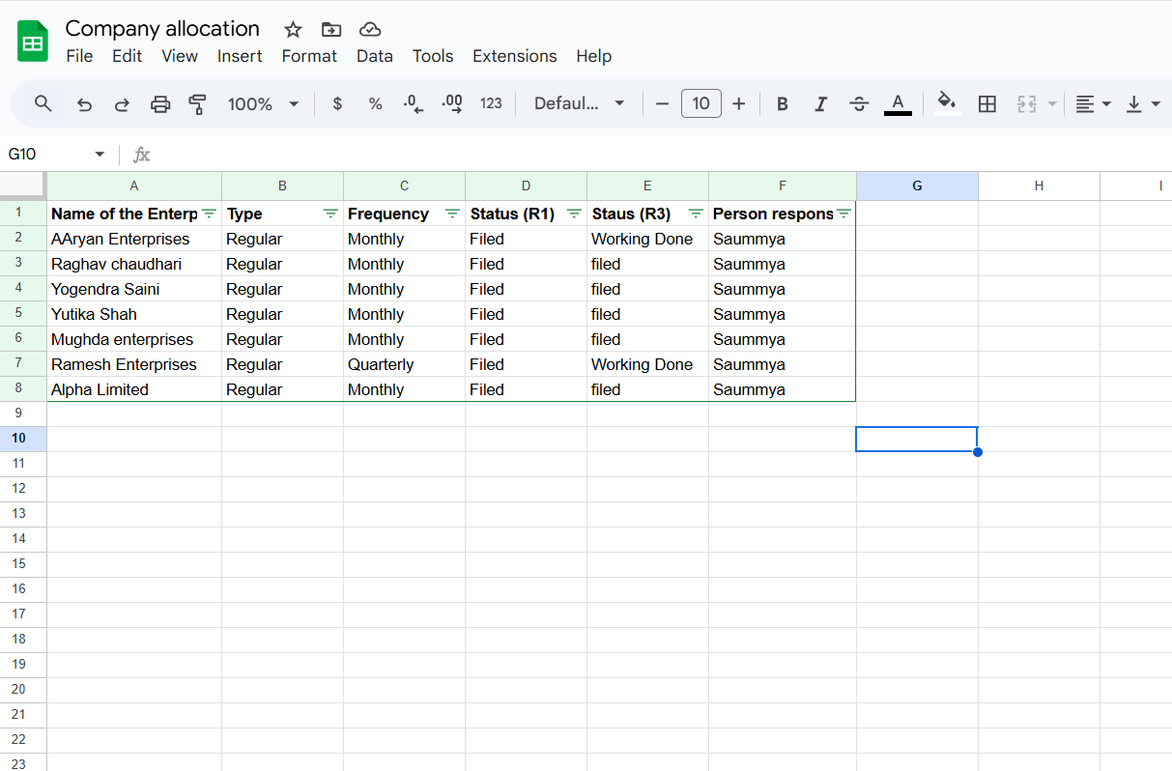

The above is the sample of clients that regularly file GSTR-1 and GSTR-3B through our company.

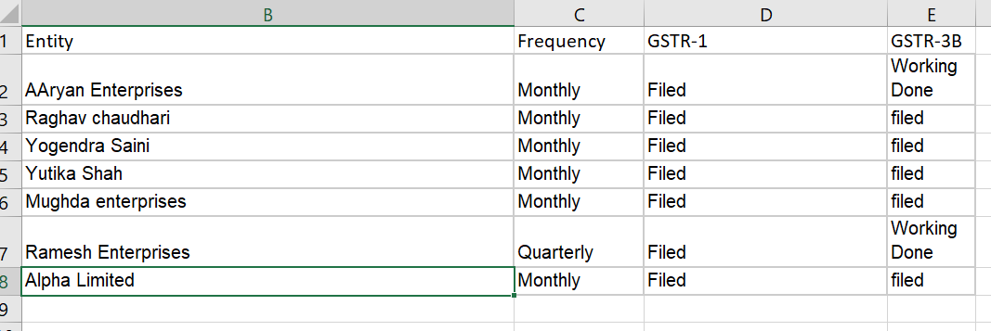

* This is the sample of companies which I worked on with my team of 3 in the month of March 2025 for filing GSTR -1 and GSTR 3B.
* Following is the details of client working I did for some of the clients.

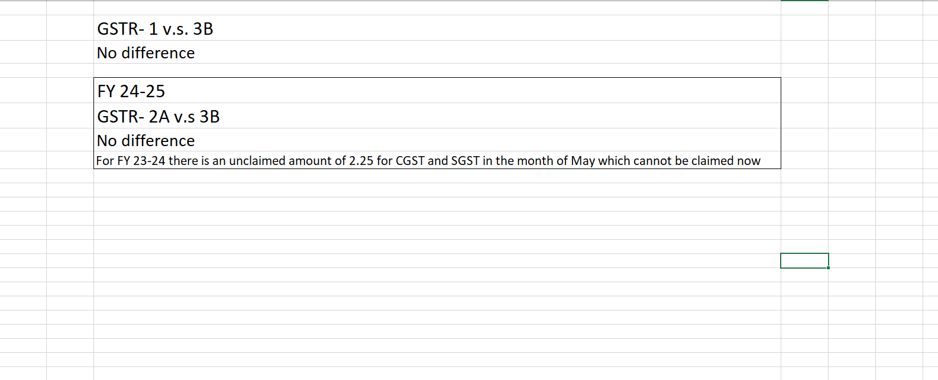

* This was the working for “Yutika Shah”

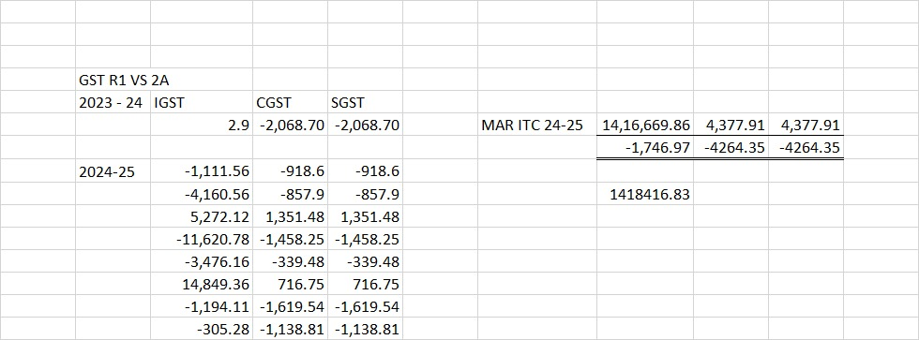

* This is the working I did for “Mughda Enterprises”

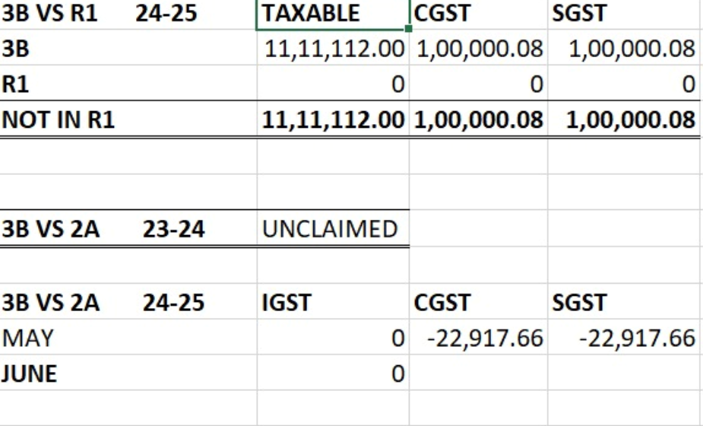

* This is the working I did for “Alpha Limited”

Since the company follows strict confidentiality policies, I wasn’t able to collect data regarding all the clients.

* **ACCOUNTING-**

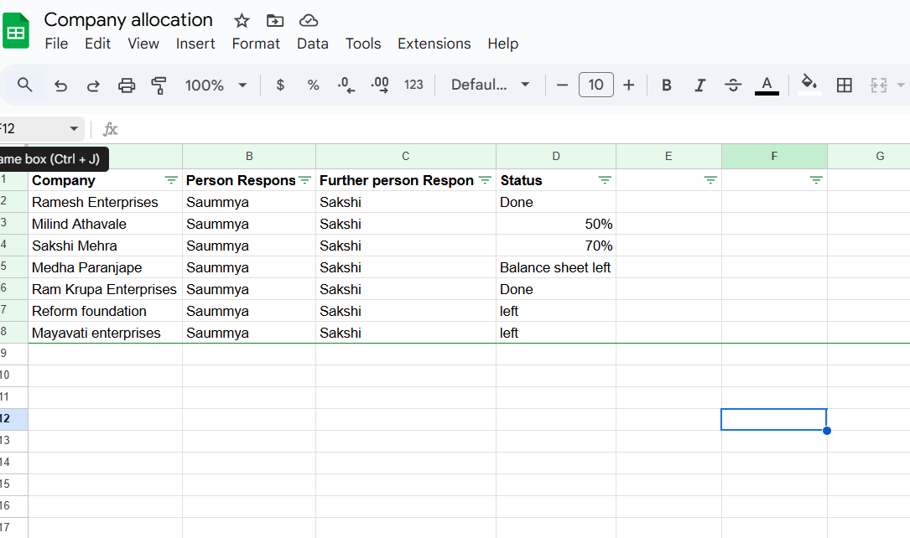

* These are sample of clients for whom we do accounting on a continuous basis.

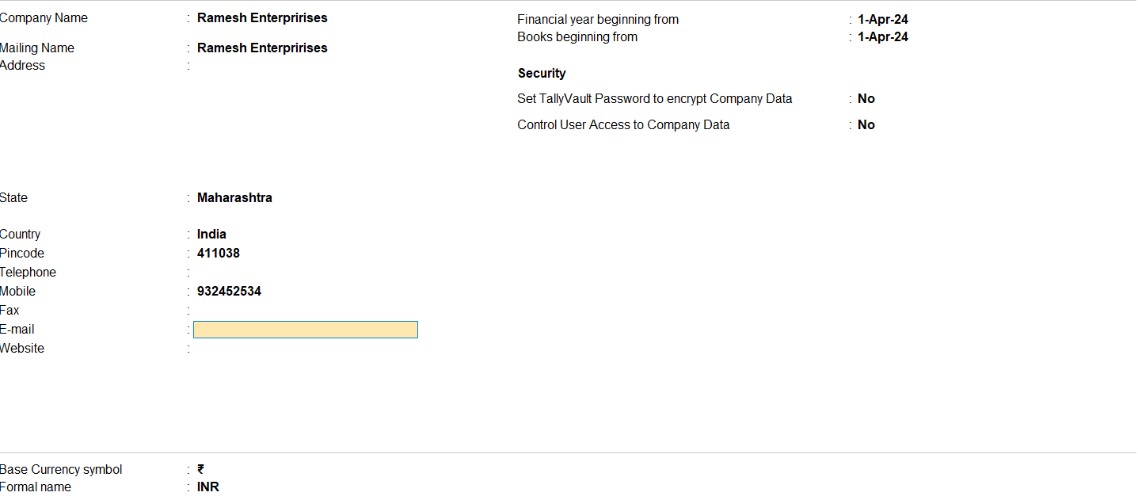

This is one of the companies “Ramesh Enterprises” for whom we do the working.

We use the software of ‘Tally’ and ‘SPEQTA GST’ for doing the working of the clients which makes it easier and efficient for us to compare the data with the actual data sent by the client since sometimes the Government website of GST can lag because of overload which may cause problems during the due dates.

# Chapter 4

# DATA ANALYSIS AND INTERPRETATION

India has adopted a dual GST model. Under Dual GST Model, the Centre and States simultaneously levy GST on complete supply chain, i.e. starting from production to distribution stage. Thus, tax is imposed concurrently by the Centre and States, i.e. Centre and States simultaneously tax goods and services. Now, the Centre also has the power to tax intra-State sales & States are also empowered to tax services. GST extends to whole of India including the Union Territory of Jammu and Kashmir.

GST is a destination-based tax applicable on all transactions involving supply of goods or services or both for a consideration subject to exceptions thereof. GST in India comprises of-

Central Goods and Services Tax (CGST) – levied and collected by Central Government.

State Goods and Services Tax (SGST) - levied and collected by State Governments/Union Territories with Legislatures.

Union Territory Goods and Services Tax (UTGST) - levied and collected by Union Territories without Legislatures, on intra-State supplies of taxable goods and/or services.

GST helped remove the cascading effect of taxes and many taxes in the old regime were subsumed by GST such as-

* + Central Excise Duty & Additional Excise Duties
  + Service Tax
  + Excise Duty under Medicinal & Toilet Preparation Act, 1955
  + CVD & Special CVD
  + Central Sales Tax
  + Central surcharges & Cesses in so far as they relate to supply of goods & services and certain other state taxes as well.
* Now, having understood the concept of GST, let us analyse and interpret different returns filed in GST.
  + **GSTR 1**- Details of all outward supplies/sales made which is to be filed on 11th / 13th of the next month depending upon the turnover. It is a monthly return
  + **GSTR 3B**- Summary of all details added in GSTR-1 and is to be filed on 20th or 22nd of the next month depending upon the turnover. It is a monthly return.
  + **GSTR 9**- It is an annual return and the due date is 31st December.
  + **GSTR 4**- It is a return for those who are registered under the composition scheme and the due date is 30th April following the previous year. It is an annual return.
  + **GSTR- 5**- It is to be filed by non- resident taxpayers and the due date is 13th of the next month. It is a monthly return
  + **GSTR-6** - Return for an input service distributor to distribute the eligible input tax credit to its branches. The due date for the same is 13th of the next month. It is a monthly return.
  + **GSTR-7** - Return to be filed by registered persons deducting tax at source (TDS). The due date for GSTR- 7 is 10th of the next month. It is a monthly return.
  + **GSTR 8**- Return to be filed by e-commerce operators containing details of supplies through them and the amount of tax collected by them. It is to be filed on 10th of the next month and is a monthly return.
  + **GSTR- 10-** Final return to be filed by a taxpayer whose GST registration is cancelled. It is to be filed when the GST registration is cancelled or surrendered. It is to be filed within 3 months from date of cancellation or date of cancellation order whichever is earlier.

These are some of the basic returns an individual can file under GST.

Practical approach to file the GST returns-

* Since I already mentioned that our office uses the software named “Speqta” for filing the GST returns, this is how the procedure for filing the returns is.
* First, we login into the Speqta Portal- This is what the screen looks like-

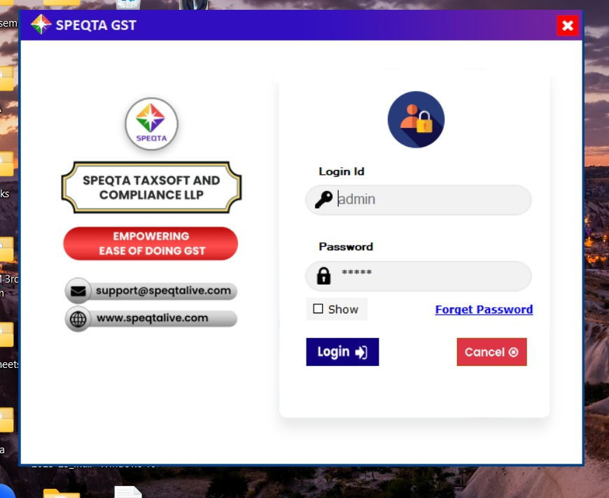

* Once we login into the portal, this is how the screen is-

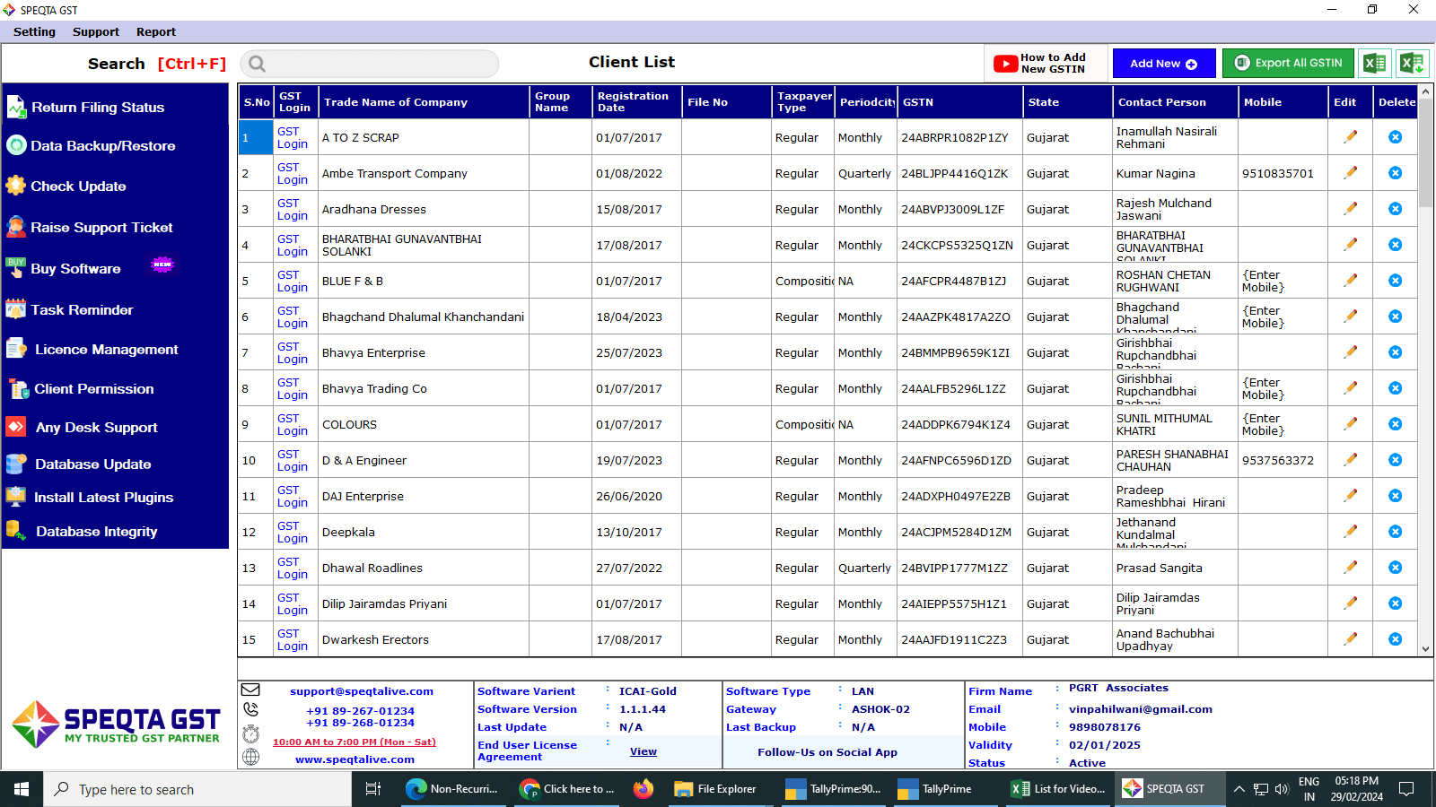

* Once you login into the portal, you can select the company using “Ctrl F” button.
* Once you select the company, you enter the period for which you want to view the details. For example, AY25-26.
* Once you select the tax period, this is what the screen looks like-

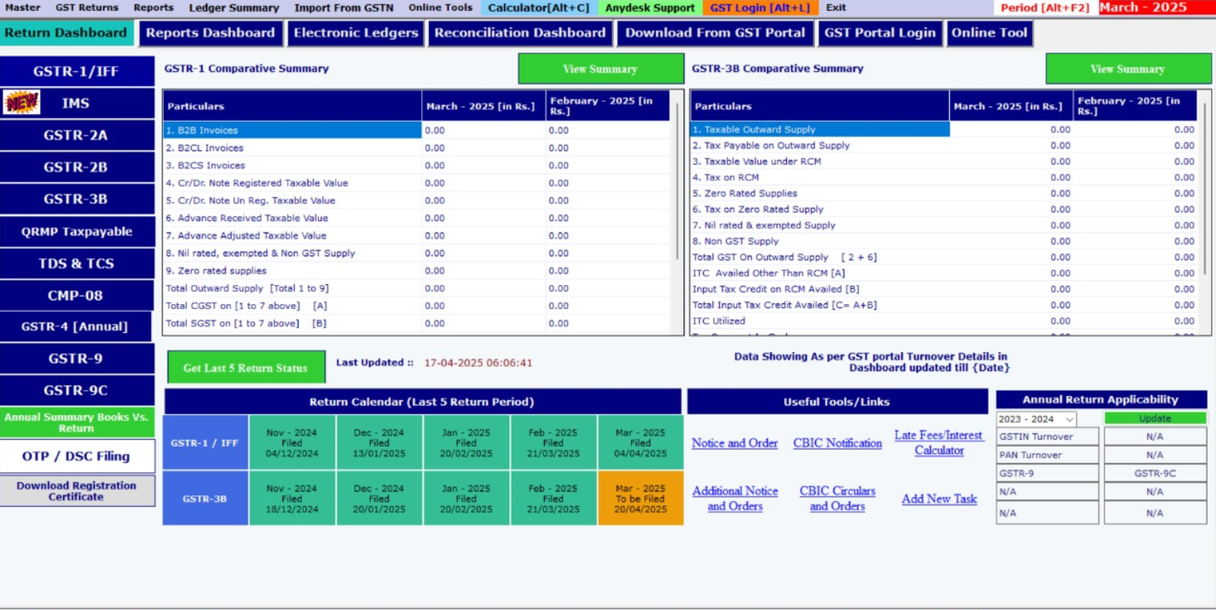

* In here, we click on reports dashboard, to view all the invoices entered in GSTR-1 and to check whether there are any more details to be entered or are there any errors.

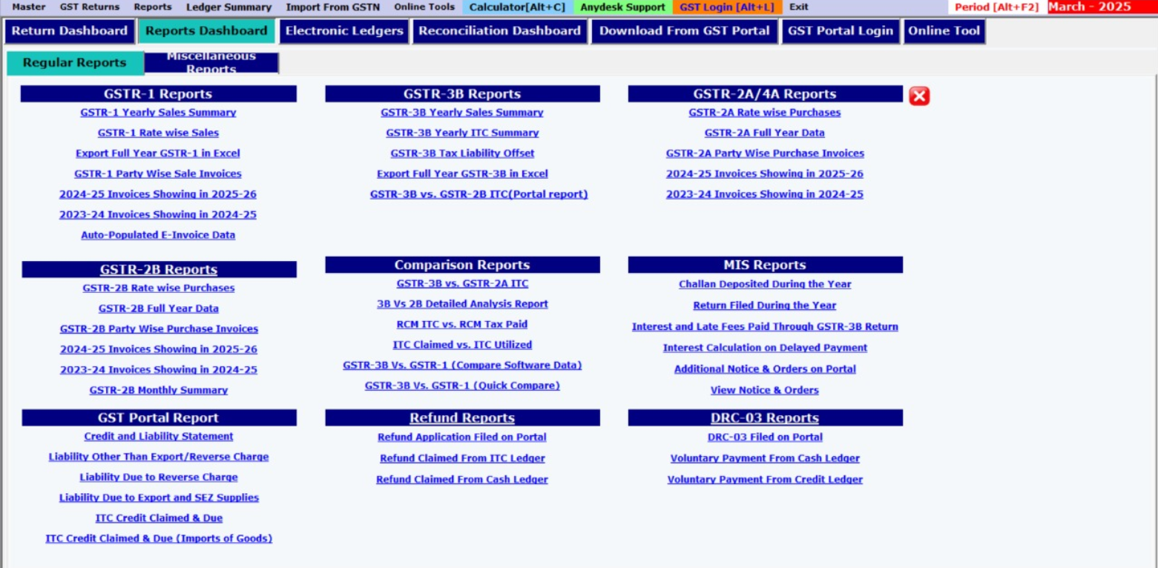

* After checking whether all the data is correctly entered, we login to the GST portal, with “Ctrl L”.

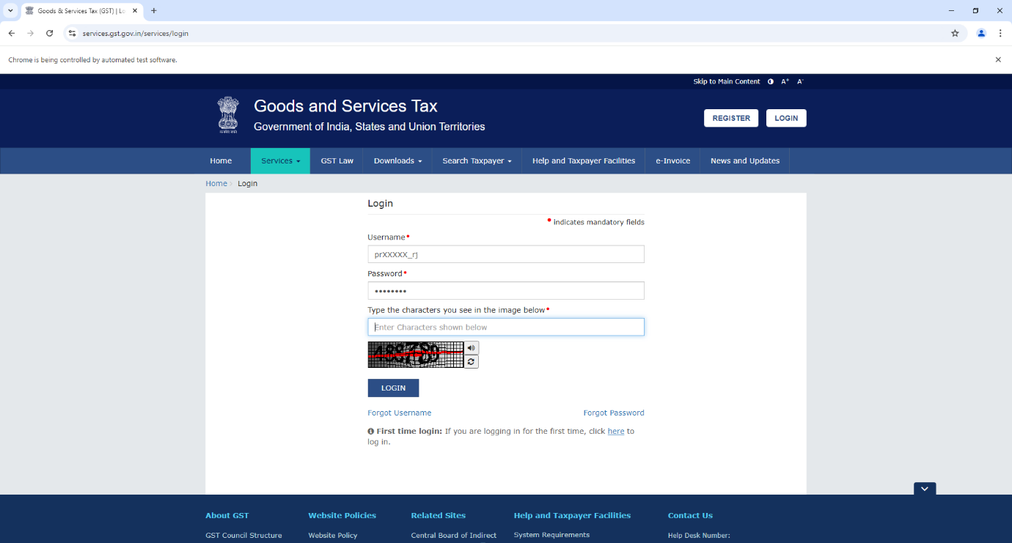

* Once we log in, we go to the Returns Dashboard and since here we are filing GSTR-1, we select the tab of “Details of outward supplies of goods and services” and click on it. Once selected, we check details of all the invoices entered and check whether any additional details need to be entered or any invoice has to be removed. We can use an offline utility or enter the details there itself.
* Once logged in into the portal we need to check whether the returns of the past period have been appropriately filed, since without that we cannot proceed further.
* Once we have checked everything, we need to click on “Proceed to file the statement” and view the summary and once everything is checked, we will file the return by selecting the authorized signatory and ask for One time Password from the client to successfully file the return.
* To check whether the return is successfully filed, we can go on “Speqta” and check.

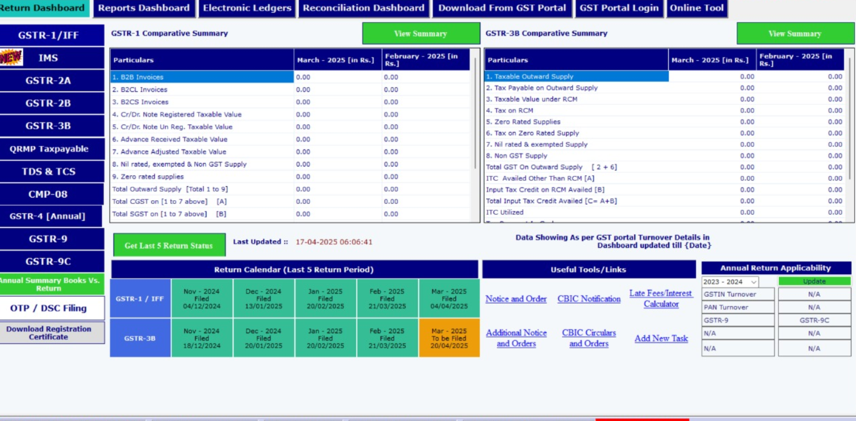

* As we can see here that GSTR-1 has been successfully filed for the month of March.
* Similar is the process for GSTR- 3B. However, in the case of GSTR-3B, we have to claim available Input tax credit and if after claiming the ITC, there is any liability left, we need to pay the tax through cash.
* Also, before filing of GSTR- 3B, we have to reconcile the balances of GSTR-1 with GSTR- 3B and GSTR 3B with GSTR 2B.
* For example, if the input tax credit available for a particular month is rupees 2,50,000 and in the GSTR 3B of the past month we have claimed amount of rupees 2,35,000, we have an unclaimed amount of rupees 15000 which we can claim in this month and reduce our liability which we have to pay in cash by rupees 15000.
* Similarly, if we have balance of 2,00,000 in our GSTR 2A and in the past month we have claimed rupees 2,50,000, then we have to reverse the excess amount or in simple words we have to pay the excess amount claimed in cash.
* **ACCOUNTING-**
* For doing the accounting of clients, we use the software of “Tally” for preparing the data.
* With the help of Tally, we can easily Audit the client’s statement of accounts or prepare the final balance sheet.
* Also, any errors can also be rectified. Now, for doing the accounting of any client, we need the balance sheet as on the latest date with all the transactions fully entered.

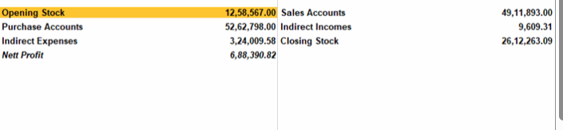

For the confidentiality of the client, all the other details have been hidden.

* Now, if I want to Tally the Sales and Purchase data from this “Profit and Loss Account”, for this, we can open Display More Reports-Account Books- Sales Register. Here, we can view month wise sales data. If we select the month “April”, we can easily tally the data with the GST software. This is because GSTR-1 is nothing but all the details of Sales.
* Just as we did for the month of “April”, we can do the same for all other months.
* Similarly, the data is tallied for “Purchases”



* For the sales data, we have to select “GSTR-1 Party wise sales invoices” and tally the data.
* For purchases, we have to select “GSTR- 2A” “Party wise Purchases invoices”

Now, to tally the bank account details for any client,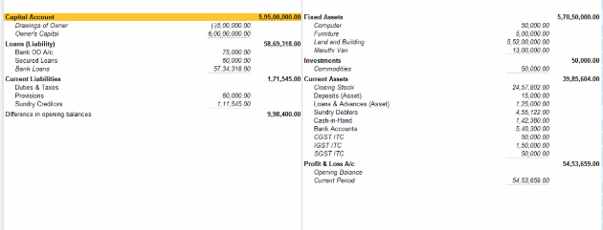

* For example, in the above balance sheet, if we want to tally the bank amount of rupees 540,000 shown in this balance sheet, we need to ask the clients to send the bank statement to match the balances.
* Once the balances of the bank are sent by the client, we check the opening and closing balances of each month to check whether they are correct.
* If some of the entries are present in Tally but they are not present in the bank statement, they are deleted from tally to match with the bank statement.
* If there are entries that are present in Bank statement but are not present in Tally, they are added in Tally to match with the bank statement.

**How to Import bank statement entries into Tally?**

* + To verify bank statement entries at the year end with Tally, first we need to mark/ enter the entries into Tally. For a company which has around 500 bank entries, it is not manually possible to manually enter the entries.
  + To solve this, there is a Tally template wherein we can copy all the transactions from the bank statement to easily import the transactions into Tally.
  + First, we need to convert the bank statement into excel.

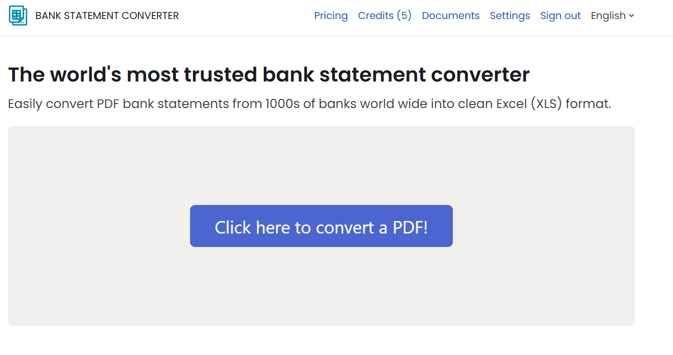

We use the website of <https://bankstatementconverter.com/> for converting bank statements to convert the same from pdf to excel.

Once the data is converted into excel, we copy the data from excel to the template of Tally.

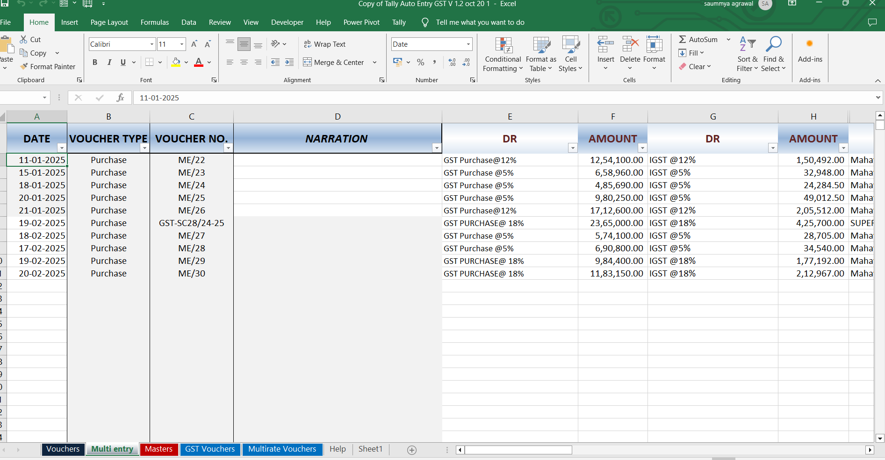

This is the template we use for entering the data.

* + Once the data is entered, we open the software of Tally.
  + We click on Ctrl + O and here we select transactions.
  + We select the File path, the file to import.
  + Once the details are selected, transactions are imported.

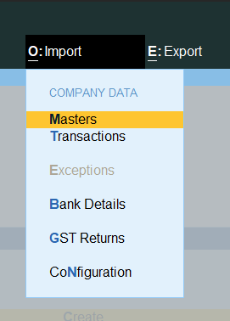

Recently, I our organization, there was a session conducted at our office where a demo of the software named “SUVIT” was conducted.

It is similar to the Tally template which we use to import entries into Tally. However instead of entering each of the entries manually which we used to do in the Tally template, this software automatically selects all the entries which we need to import. We just need to enter the ledger in which we want to import the data and the entries are automatically entered into Tally without much effort.

By using this software, we can save a lot of time and complete the accounting of the client on a timely basis.

Also, we can avoid errors which generally take place while entering entries into the Tally template manually.

Also, I learnt how to match the Branch and Divisions of some companies. The process I learnt was as follows-

For example, if I want to match the branch and Division of Ram Krupa enterprises as I mentioned in the list of entities, I have been assigned to do the accounting for, I opened the company account in Tally.

Once the Tally is opened, I went to Balance sheet of the company and there I went to the Current Assets of the Company and opened the Branch and Divisions of the company.

For example, if the Branch name is Mahadev Enterprises, I opened the Tally of that company and in the loans and liability side of that branch, I find the name of Ram Krupa Enterprises and match the balance.

For example, if in Ram Krupa enterprises they have received payment of rupees 35000, then it should be shown in the payment side of Mahadev enterprises.

## Results Of the Survey.

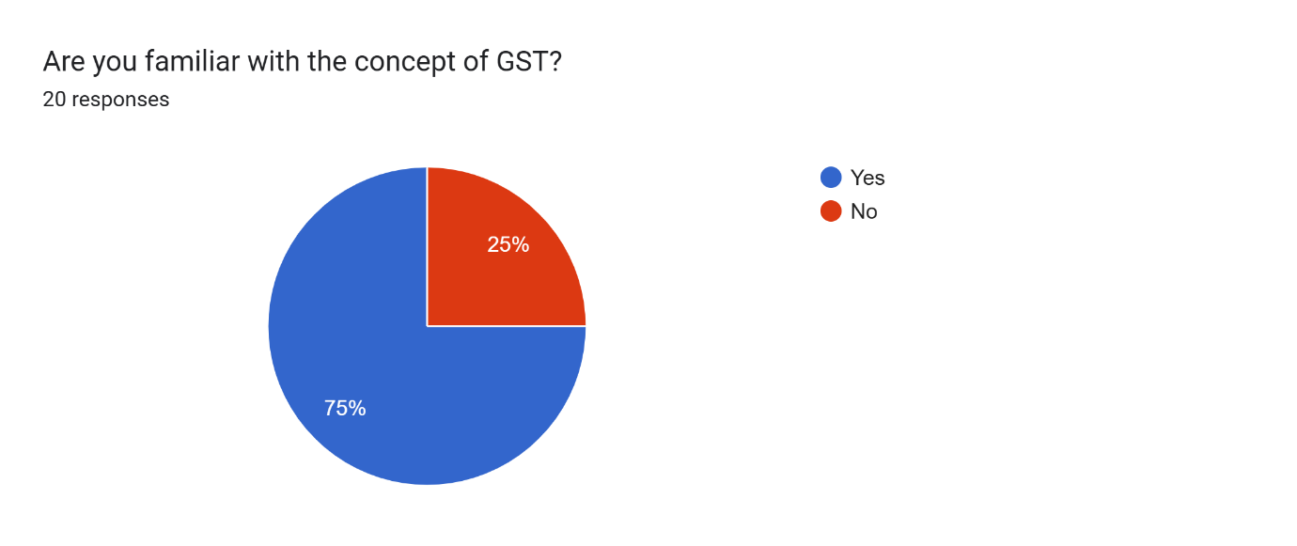

* Source- Survey Conducted

75% of the respondents are aware with the concept of GST. The reasons of this can be that they have been registered under GST or they have studied the same previously.

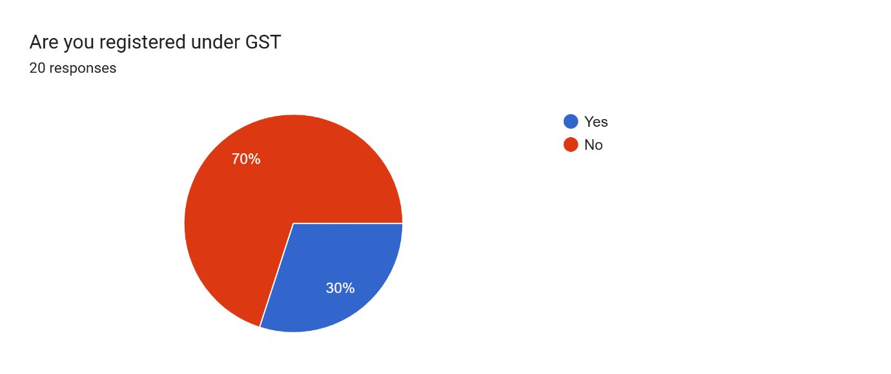

* Source- Survey Conducted

70% of the respondents are not registered on the website of GST. The reason for the same can be that they do not surpass the threshold limit to be registered under GST or they don’t have much knowledge about the same.

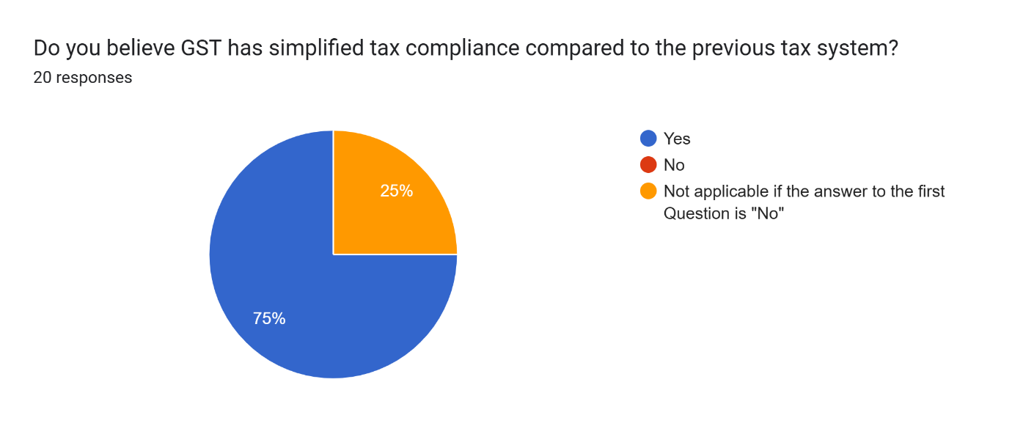

* Source- Survey Conducted

75% of the respondents believe that GST has simplified tax compliance compared to previous tax system. The reason for the same can be that the old regime consisted many taxes and the new tax regime removed the cascading effect of taxes.

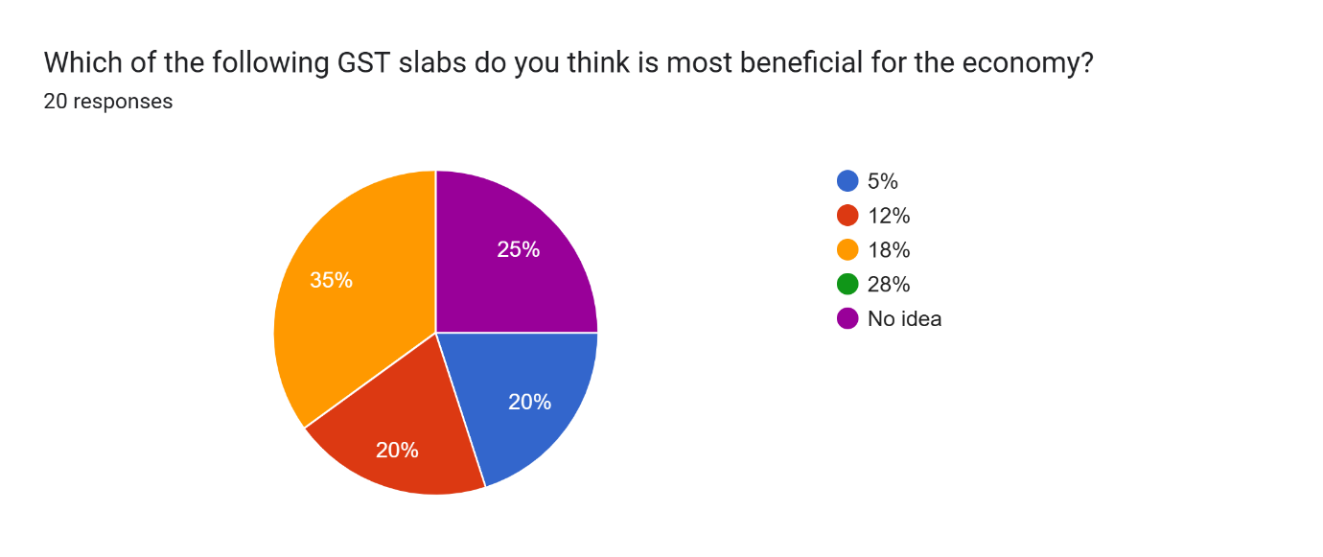

* Source- Survey Conducted

35% people think that 18% GST rate is the most beneficial one. The reason for the same could be that the greater the revenue for the government, the greater they could spend for public welfare.

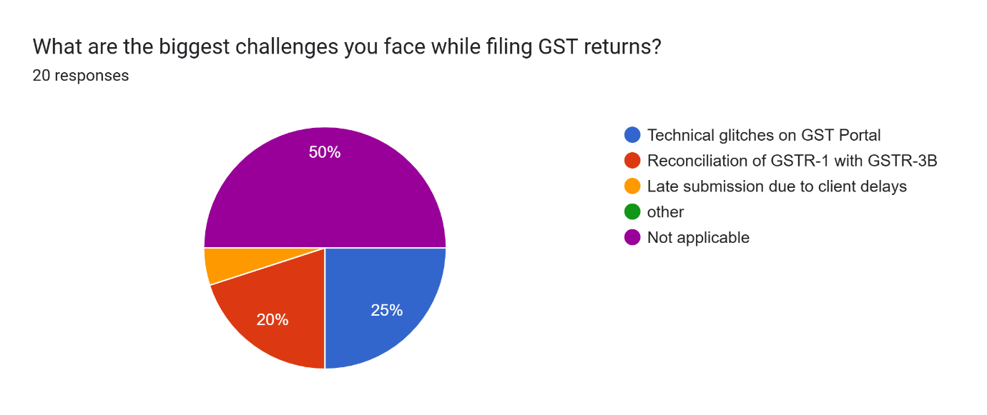

* Source- Survey Conducted

According to 25% of the respondents, technical glitch on GST portal is one of the major challenges while filing the returns. The reason for the same could be while filing the returns, the load of the website increases causing server issues.

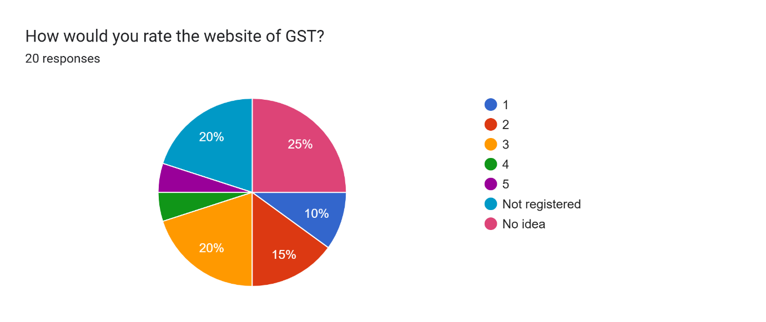

* Source- Survey Conducted

As we can see, respondents have different opinions regarding the GST website. As here we can see, people who are no registered but file returns for others can have also rated the website.

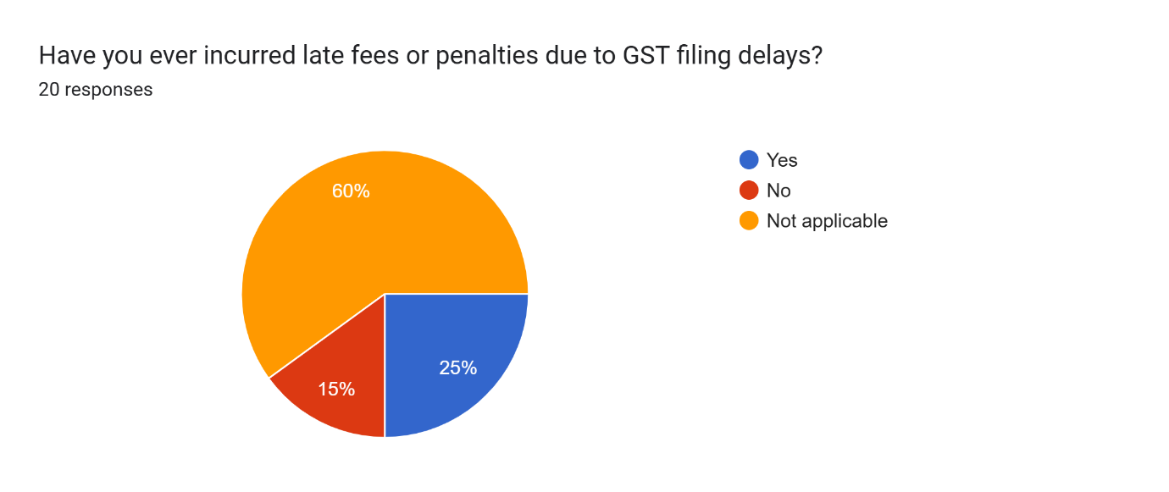

* Source- Survey Conducted

Around 25% of the people have incurred late fees while filing GST returns. The reason for the same could be unavailability of the data.

I had also put a question regarding the recommendations on how to improve the GST website. These are the responses that I got-

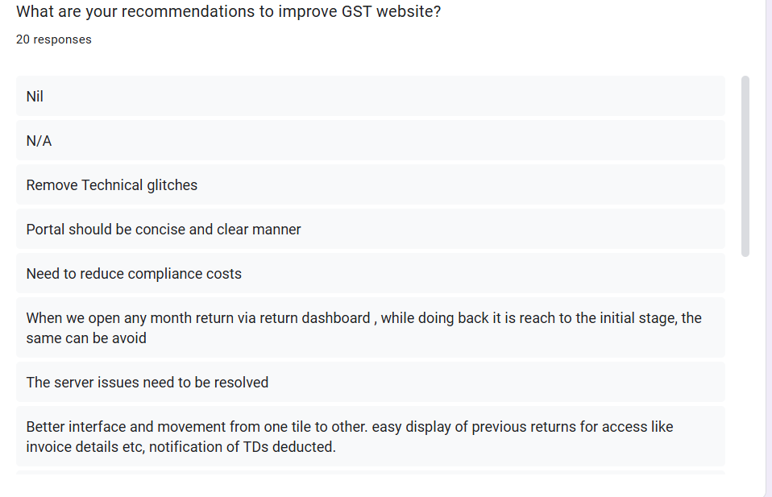

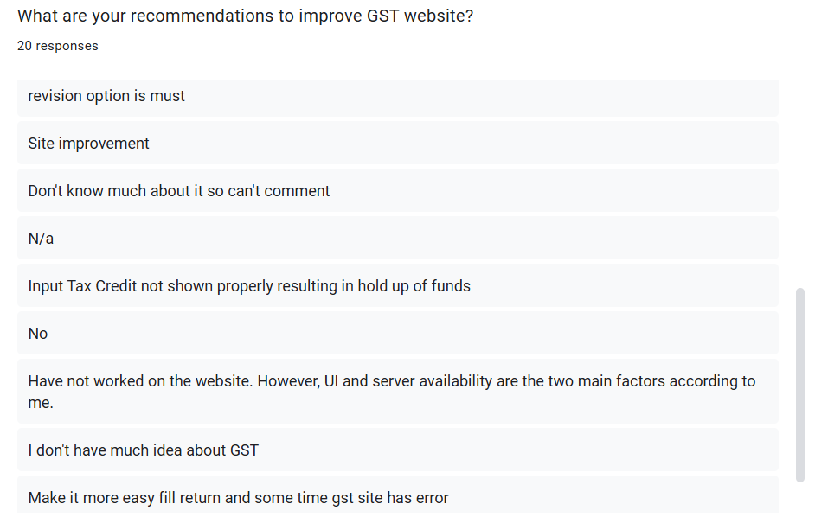.

As we can see in the recommendations given above, we can see that many people feel that the server and the site need to be improved.

Also, according to one of the responses, compliance costs need to be reduced.

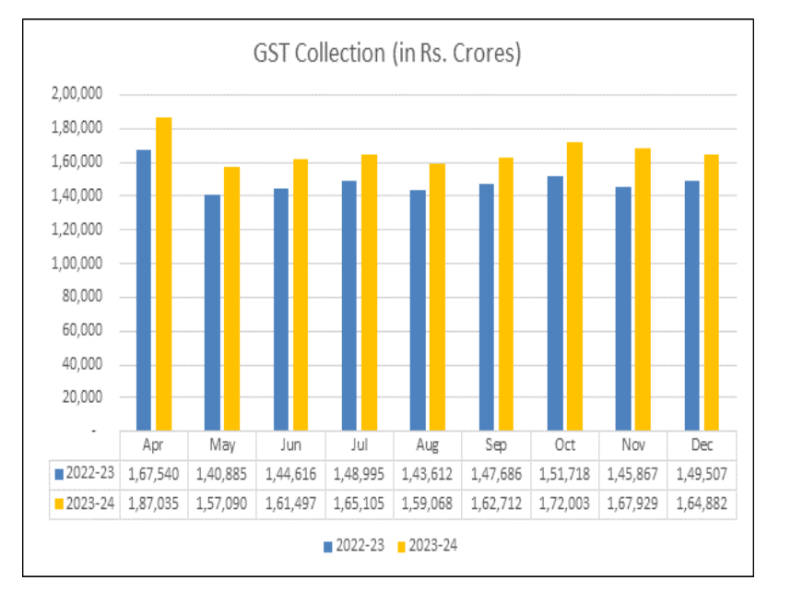

* This is the data collected from the GST council website. As we can see, the total revenue from GST returns was rupees 1,64,882 crores which is greater than last year December returns. However, it is lower than last month.
* According to the GST website, the total returns filed in the month of December 2024 were around 1,21,32,993.

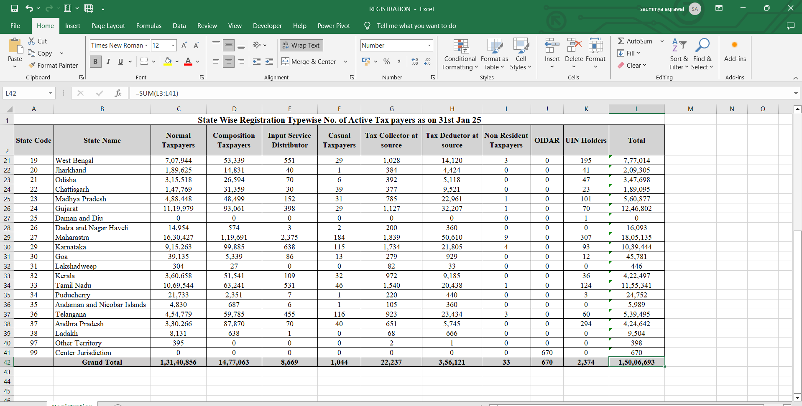

As seen above, as per the official website of GST, 1,50,06,693 people were registered in GST as on 31st Jan 25.

* I collected some data from my firm CA Dhiraj Ostwal and Co. to see how many GST returns are filed.
* Around 50 clients file timely GSTR returns i.e. they provide timely data.
* 25 clients provide data after due date which leads to late fees.

# **Chapter 5**

# **SUMMARY OF FINDINGS, CONCLUSIONS AND RECOMMENDATION**

# Summary of Analysis

* While doing the survey, I talked to some of the respondents. When spoken to, he had no knowledge about GST and its benefits. So, according to me, it is important that every individual should have basic knowledge of GST.
* While filing the GST returns, I found out that few of the clients are ready to pay late fees instead of filing returns on time. This should be corrected.
* While doing the accounting of the clients, clients do not respond to queries on time.
* In all, I learnt the importance of filing timely returns and the importance of having knowledge about GST.
* I also found out how to file GSTR-1, GSTR- 3B, nil GSTR-1 returns which are very importance for individuals who are registered under GST.
* I also learnt how the website of GST works and what adjustments need to be done.
* I learnt about the various GSTR returns that are to be filed such as GSTR-5, GSTR-9.

# Findings

* Learnt how to handle the clients.
* Learnt how to file GSTR returns.
* Learned how to export details from tally to Excel and then Portal.
* Learnt about the tally software.
* Learnt about how to import data into tally.
* Learnt about to reconcile data between returns.
* Learnt about how to make adjustments in the input tax credit
* How to match sales and purchases data into tally.

# 5.3 Suggestions

* The portal should be made more robust to handle load since on the due date generally the website lags.
* The accounting practices of the firm should be improved and proper record of the data should be kept.
* Everyone should be given a basic knowledge about GST whether registered or not and whether from a commerce background or not.
* The clients should try and file the returns within the due dates.

# 5.4 Conclusion

* Implementation of GST is one of the most beneficial decisions introduced by the Government of India.
* It has removed many problems that were there in the old tax regime.
* Also, the government has introduced many facilities that have made it easier for people having less turnover to register on the website.
* Many consultants also provide the service of filing GST returns on basis of their clients making it easier for them.
* Also, I gained a lot of practical exposure while doing this internship which would definitely be helpful for me in the future.
* It helped me to understand real life clients and how to deal with their queries and how to handle them.
* I also learnt the importance of team work.

I would also like to thank my firm for giving me this opportunity.

# Bibliography

# Bibliography

|  |  |
| --- | --- |
| [1] | M. Bala, “GST in India: A Critical Review.,” Guru Nanak Girls College, Haryana, 2018, March 21. |
| [2] | A. K. M. Y. R. Jarad, ““A Comparative Study of GST Return”,” *International Journal of Research Publication and Reviews,* p. 6, nov 2024. |
| [3] | S. V, “GOODS AND SERVICES TAX: BARRIERS IN FILING GST RETURNS,” Institution OF Electronics and Telecommunication Engineers, Bengaluru, 2017. |
| [4] | R. Manivel, “GST AND TECHNOLOGY,” *Research Gate,* September 2017. |
| [5] | ICAI, Chapter 1 “GST In India- An Introduction”, Delhi: ICAI, 2024. |
| [6] | ICAI, Chapter 15 “Returns”, Delhi: ICAI, 2024. |
| [7] | J. SENTHIL KUMAR, “INFLUENCE OF TALLY ERP 9,” may 2019 2020. [Online]. Available: https://www.jetir.org/papers/JETIRBP06052.pdf. |
| [8] | F. I. J. Imhanzenobe, “Information technology and the accountant today: What has really changed?,” *Journal of Accounting and Taxation,* vol. Vol.12, no. 1, p. 60, 2020. |

[9]. https://gstcouncil.gov.in/gst-system-statistics

[10] https://www.gst.gov.in/

[11] Database at Dhiraj Ostwal and Co.